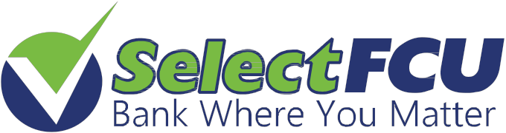

DIVIDEND RATE SCHEDULE

DEPOSIT ACCOUNTS |  | RATE / APY
Shares | $5.01 - $24,999.99  $25,000.00 - $49,999.99  $50,000.00 & ABOVE | .25% - .25%  .25% - .25%  .25% - .25%
Savers Club Account | $10.00 & ABOVE | .35% - .35%
SaveUSA | $200.00 & ABOVE | .25% - .25%

IRA ACCOUNTS |  | RATE/APY
IRA Shares | $100.01 - $9,999.99 | 1.24% - 1.25%
 | $10,000.00 - $19,999.99  $20,000.00 - $49,999.99 | 1.24% - 1.25%  1.24% - 1.25%
$50,000.00 & ABOVE 1.24% - 1.25%
IRA CERTIFICATES
12 Months  24 Months | $5,000.00 & ABOVE  $5,000.00 & ABOVE | 2.28% - 2.30%  2.47% - 2.50%
SHARE CERTIFICATES |  | RATE / APY
12 Months | $500.00 - $24,999.99 | 2.28% - 2.30%
 | $25,000.00 - $49,999.99 | 2.28% - 2.30%
 | $50,000.00 & ABOVE | 2.38% - 2.40%
18 Months  SPECIAL PROMO | $25,000.00 & ABOVE | 2.57% - 2.60%
24 Months | $500.00 - $24,999.99 | 2.47% - 2.50%
 | $25,000.00 - $49,999.99 | 2.47% - 2.50%
$50,000.00 & ABOVE 2.57% - 2.60%
36 Months | $500.00 - $24,999.99 | 2.76% - 2.80%
 | $25,000.00 - $49,999.99 | 2.76% - 2.80%
$50,000.00 & ABOVE 2.86% - 2.90%

Effective: 12/20/2018

A.P.Y. = Annual Percentage Yield

**RATES ARE SUBJECT TO CHANGE

